## Materials and links

TPS75901KTTR (3.3 regulator)

<https://www.digikey.ca/product-detail/en/texas-instruments/TPS75901KTTR/296-29784-1-ND/2769170>

ACPL-072L-500E (opto-coupler)

<https://www.digikey.ca/product-detail/en/broadcom-limited/ACPL-072L-500E/516-3131-1-ND/4969461?utm_source=snapeda&utm_medium=aggregator&utm_campaign=symbol>

GRM188R60G476ME15D (47uF Cap)

<https://www.digikey.ca/product-detail/en/murata-electronics-north-america/GRM188R60G476ME15D/490-13246-1-ND/5877454?utm_source=snapeda&utm_medium=aggregator&utm_campaign=symbol>

RR0816P-513-D (51k Res)

<https://www.digikey.ca/product-detail/en/susumu/RR0816P-513-D/RR08P51.0KDCT-ND/432765>

RT0603BRD0730K1L (30.1k Res)

<https://www.digikey.ca/product-detail/en/yageo/RT0603BRD0730K1L/YAG1631CT-ND/5139079>

NCP705MTADJTCG (1.85 regulator)

<https://www.digikey.ca/product-detail/en/on-semiconductor/NCP705MTADJTCG/NCP705MTADJTCGOSCT-ND/8538627>

GRM188R60J105KA01D (1uF Cap)

<https://www.digikey.ca/product-detail/en/murata-electronics-north-america/GRM188R60J105KA01D/490-1550-1-ND/587755>

ERJ-3GEY0R00V (98.8k Res)

<https://www.digikey.ca/product-detail/en/panasonic-electronic-components/ERJ-3GEY0R00V/P0.0GCT-ND/134711>

RC0603FR-07130KL (130k Res)

<https://www.digikey.ca/product-detail/en/yageo/RC0603FR-07130KL/311-130KHRCT-ND/729882>

GRM1885C1H103JA01D (10nF Cap)

<https://www.digikey.ca/product-detail/en/murata-electronics-north-america/GRM1885C1H103JA01D/490-9666-1-ND/4934772?utm_source=snapeda&utm_medium=aggregator&utm_campaign=symbol>

1x8 male header x5

1x10 male header x1

18x2 male header x1

3x2 female header x1

Haven’t search up the links for headers yet, but they should be pretty common..

DC21MMX

DC Barrel power jack

Left half of the chip:

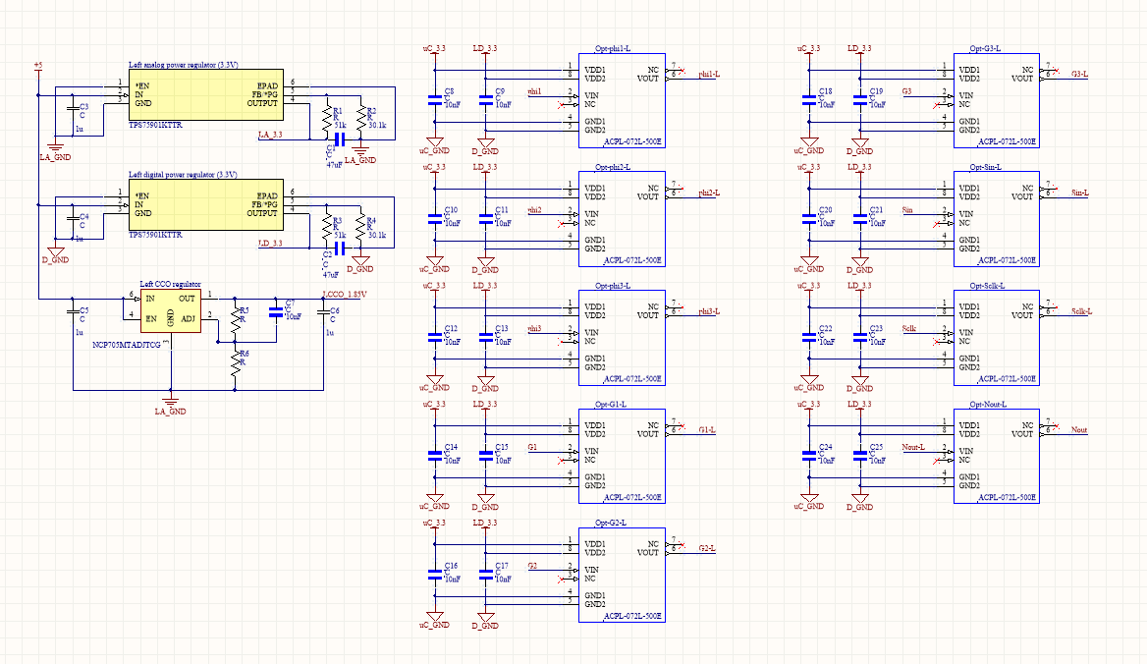

Right half of the chip:

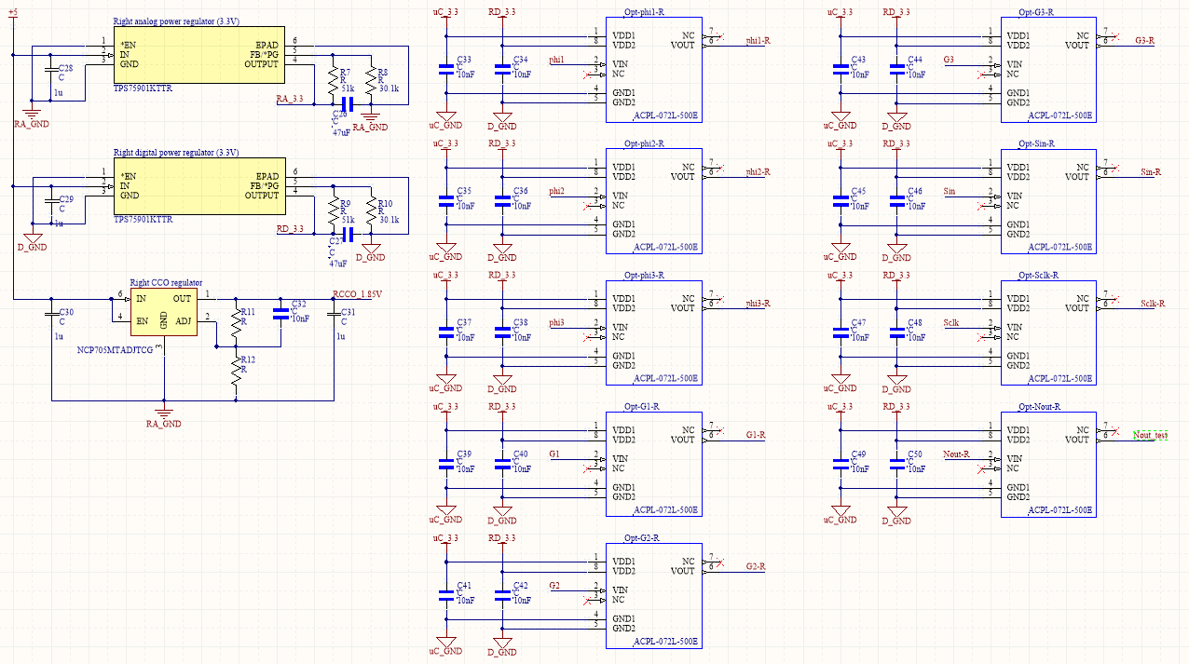

Common part

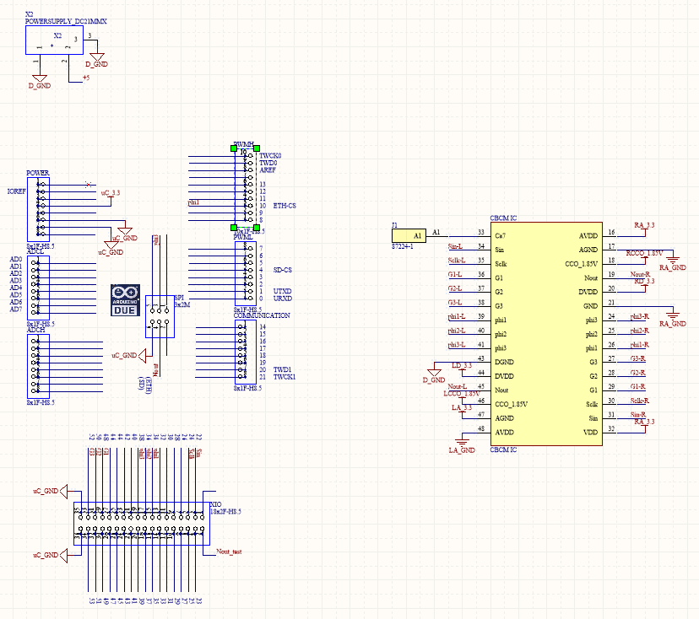

PCB layout:

